**EMBEDDED SYSTEMS-I**

__________________________________



By

**GROUP 20 (SESSION 2022)**

**2022-MC-56**

**2022-MC-61**

**2022-MC-77**

To

**SIR SHUJAT ALI**

**“SEMESTER PROJECT REPORT- SLIDER ROCKER MECHANISM + HELICAL SCREW.”**

_____________________________________

Mechatronics and Control Engineering Department

**University of Engineering and Technology, Lahore**

**TABLE OF CONTENTS**

|  |  |  |
| --- | --- | --- |
| **SR NO** | **CONTENT** | **PAGE NO** |
| **1** | **INTRODUCTION** | **3** |
| **2** | **CAD-MODELLING OF MECHANISM** | **3** |
| **3** | **DESCRIPTION OF COMPONENTS** | **4** |
| **4** | **CIRCUIT DIAGRAM AND SCHEMATIC OF ICB** | **9** |
| **5** | **PINOUTS OF EACH COMPONENT** | **11** |
| **6** | **REFERENCES** | **11** |

**INTRODUCTION**

Our ES project showcases an innovative Slider Rock Mechanism incorporating a Helical Screw and multiple Stepper Motors for enhanced functionality. With one stepper motor dedicated to tying and untying the string in both clockwise and anticlockwise directions, and a servo motor for precise thread triggering, our system ensures meticulous control in linear motion applications. Additionally, the inclusion of another stepper motor facilitates angle adjustment by moving the chain, further enhancing the versatility and precision of our mechanism.

**CADMODELLING OF MECHANISM**

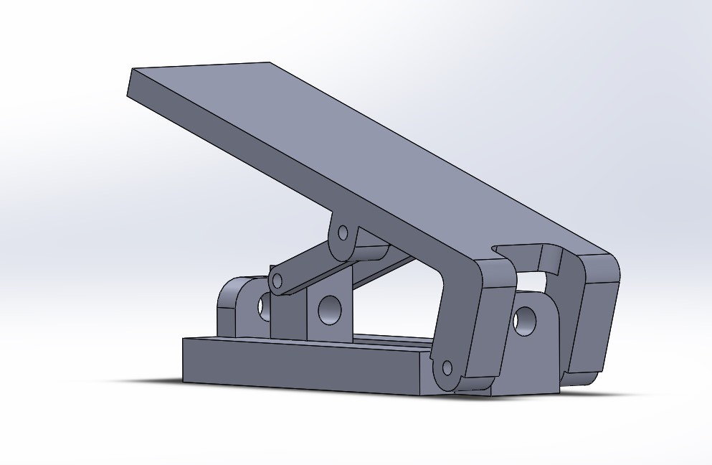

*FIG 1: CADMODELLING*

**DESCRIPTION OF COMPONENTS USED**

**SERVO MOTOR**

The SG-90 is a popular micro servo motor known for its compact size and lightweight design, making it ideal for small-scale projects and robotics. It operates on low voltage and offers precise angular control with a rotation range of approximately 180 degrees. The SG-90 is commonly used in RC planes, cars, and robotic arms due to its quick response time and affordable price. It typically consumes low power, making it suitable for battery-operated applications. Despite its small size, the SG-90 can generate a considerable amount of torque relative to its weight, making it a versatile choice for hobbyists and makers.

**SPECIFICATIONS**

* Operating Voltage: 4.8~6.0V
* Operating Speed: 0.12sec/60 degree (4.8V) ~0.1sec/60 degree (6.0V)
* Torque: 1.6kg/cm (4.8V)
* Dead Band Width: 5usec
* Temperature Range: -30~ 60
* Cable Length: 25cm (about 9.84 in)
* Servo Type: Analog Servo
* Brand Model**:** Tower Pro SG90

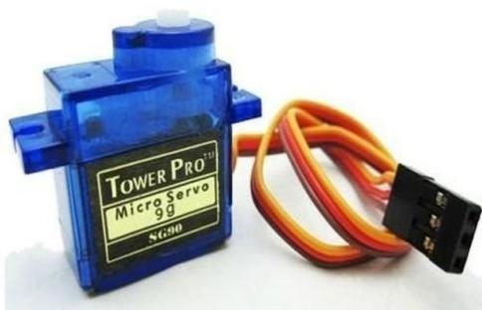

*FIG 2: SERVO MOTOR*

*It has three wires-orange wire is connects with GPIO pin, red with Vcc & brown with ground*

*In our project, it is used to trigger the thread to push the ball*

**STEPPER MOTOR**

The NEMA 17 stepper motor is a widely used motor known for its versatility and compatibility with various applications. It features a standard frame size of 1.7 x 1.7 inches (43.18 x 43.18 mm) and comes in different configurations, such as bipolar and uni-polar. The NEMA 17 motor offers precise control over angular movement, typically with a step angle of 1.8 degrees per step, making it suitable for applications requiring accurate positioning, such as 3D printers, CNC machines, and automation systems. It operates using a pulsed input, with each pulse causing the motor to move a specific increment, allowing for controlled and synchronized motion in machinery and robotics.

**SPECIFICATIONS**

* Shaft Diameter= 5mm (about 0.2 in)
* Step Angle: 1.8°
* Phase Current: 1.2A
* Phase Resistance: 1.5Ohm
* Phase Inductance: 2.8mH
* Holding Torque: 40N.cm
* Braking Torque: 2.2N.cm
* Rotor Inertia: 54g.cm;
* Wire: 4(Blue, green, black, red)
* Max. Temperature Rise: 80℃ (rated current, 2 phase on)
* Operating Temperature: -20℃~+70℃
* Insulation Resistance: 100 MΩ Min., 500VDC
* Radial Clearance: 0.02Max. (450g (about 15.87 oz)-Load)
* Axial Clearance: 0.08Max. (450g (about 15.87 oz)-Load)
* Max. Radial Pressure: 75N (20mm (about 0.79 in) from the flange)
* Max. Axial Pressure: 15N

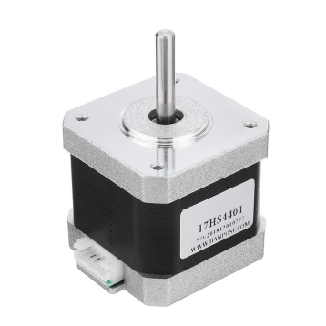

*FIGURE 3: STEPPER MOTOR*

*In our project we have used two stepper motors;*

* ***STEPPER MOTOR 1:*** *It is used to tie and untie the thread & by rotating in clockwise and anti-clockwise direction.*
* ***STEPPER MOTOR 2:*** *It adjusts the angle by rotating the chain attached to it*.

**MOTOR DRIVER**

The A4988 motor driver is a widely used stepper motor driver known for its simplicity and reliability. It supports bipolar stepper motors and provides micro stepping capabilities, allowing for smooth and precise motor control. The driver can handle motor currents up to 2A per phase and features adjustable current limiting to protect the motor from overheating. It operates using a step and direction input interface, making it compatible with various micro controllers and control systems. The A4988 also includes built-in protection features such as thermal shutdown and over-current protection, enhancing its durability and safety in applications like 3D printers, CNC machines, and robotic systems.

**SPECIFICATIONS**

* Supply Voltage: 8-35 VDC.
* Current: 1.0A (no heat sink).
* Current: 2.0A (with heat sinking).
* logic input: 3 – 5.5V.
* Automatic current decay mode detection/choice.
* Mixed with slow current decay mode.
* The low power dissipation of synchronous rectifier.
* Internal UVLO (ultra voltage lockout).
* Crossover current protection.
* Thermal shutdown circuit.
* Ground fault protection.
* Loading and short circuit protection.
* The optional five-step mode: full, 1/2, 1/4, 1/8 and 1/16.

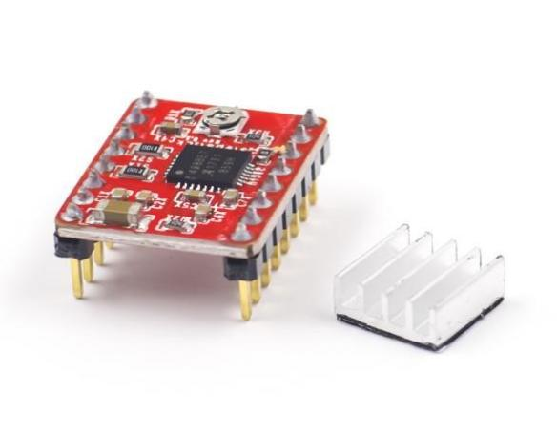

*FIGURE 4: STEPPER MOTOR DRIVER(A4988)*

**ULTRA-SONIC SENSOR**

An ultrasonic sensor is a device that uses sound waves that humans can't hear to measure how far away something is or find objects. It works by sending out sound waves and then measuring how long it takes for those waves to bounce back after they hit something. This helps it figure out how close or far away an object is. Ultrasonic sensors are useful because they don't need to touch the object to measure it, and they can work in different places. People often use them for things like detecting obstacles, checking levels, or sensing when something is nearby, especially in machines and cars.

**SPECIFICATIONS**

* Operating voltage: DC5V
* Static current: 5mA
* Operating current: 30mA
* Operating range: 25cm ~ 4.5m
* Resolution: 0.5cm
* Detecting Angle: < 70°
* Operating Temperature: -10 ~ 70°C
* Cable Length: 2.5m
* Dimension: 41mm * 28.5mm/1.61*1.12 inches
* Weight: 54g

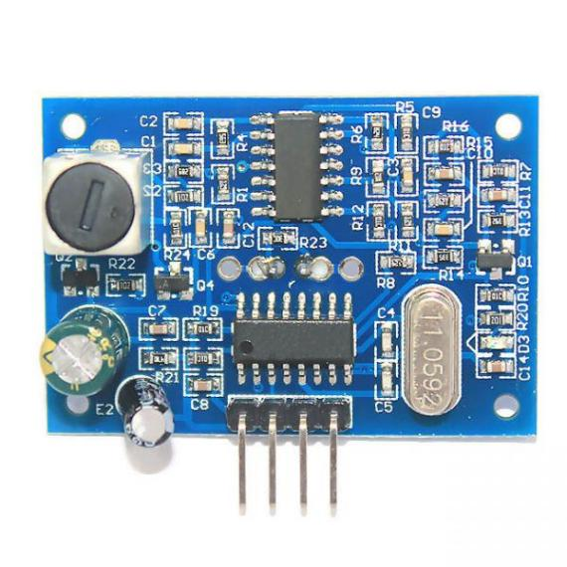

*FIGURE 5: ULTRASONIC SENSOR*

**CIRCUIT DIAGRAM & ICB SCHEMATIC**

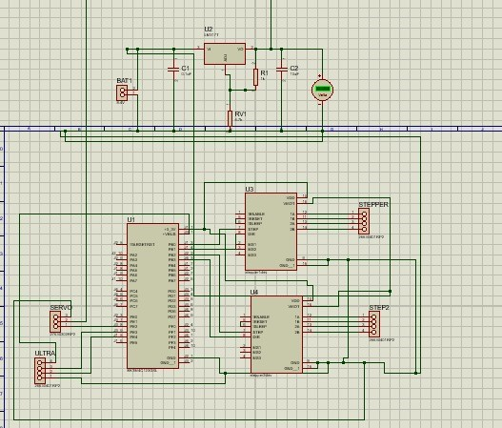

*FIGURE 6: CIRCUIT DIAGRAM*

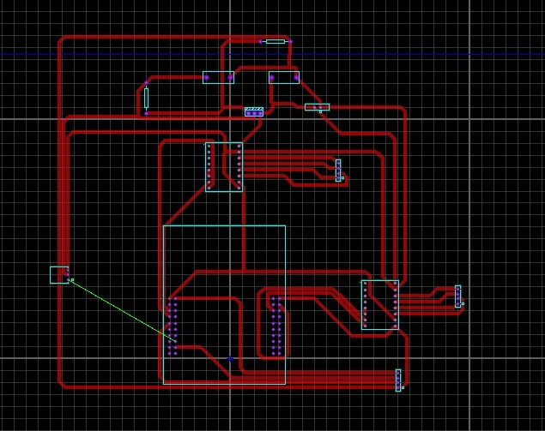

*FIGURE 7: CIRCUIT DIAGRAM*

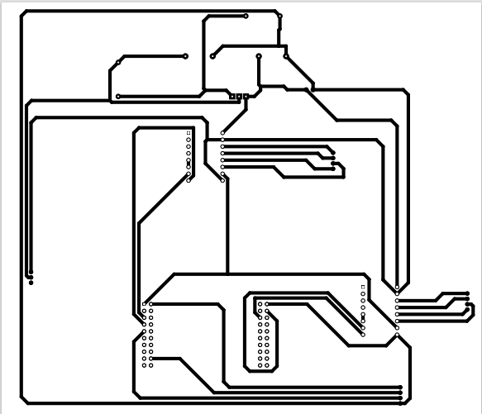

*FIGURE 8: ICB SCHEMATIC*

**PINOUTS OF EACH COMPONENT**

* **SERVO MOTOR:** PE1
* **STEPPER MOTOR 1:** PA2, PA3
* **STEPPER MOTOR 2:** PE2, PE3

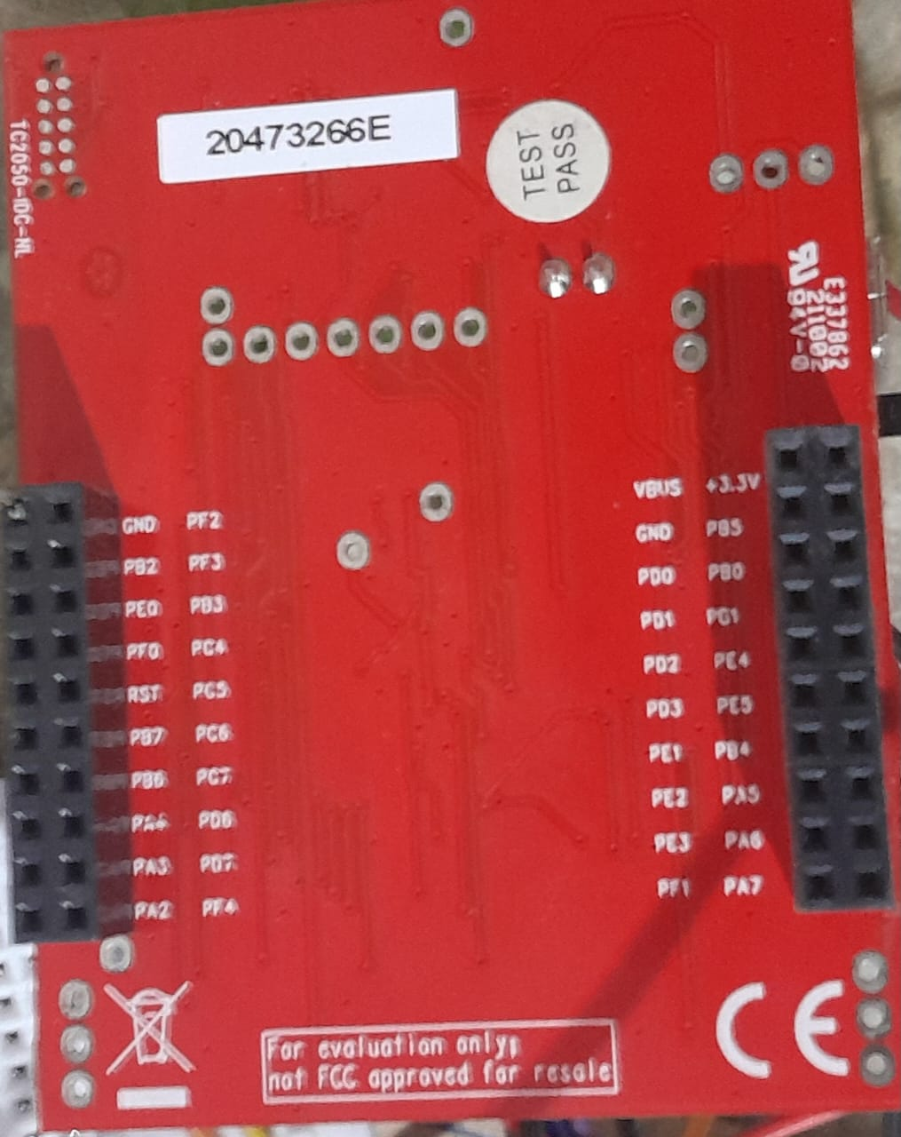

+3.3V (VCC)

GROUND

PA2

(STEPPER MOTOR 1)

PA2

(STEPPER MOTOR 1)

PE 1

(SERVO MOTOR)

P

*FIGURE 9: PINOUTS OF EACH COMPONENT*

PE 3

(STEPPER MOTOR 2)

PE 2

(STEPPER MOTOR 2)

**REFERENCES**

* <https://www.pasco.com/products/guides/projectile-launchers>
* <https://www.youtube.com/>
* <https://digilog.pk/products/towerpro-sg90-sg-90-180-degree-degree-servo-motor-in-pakistan>
* <https://digilog.pk/products/nema-17-4-wire-bipolar-stepper-motor-nema17-stepper-motor-in-pakistan>
* <https://chatgpt.com/?oai-dm=1>
* <https://digilog.pk/products/jsn-sr04t-water-proof-ultrasonic-sensor-module-distance-measuring-sensor-in-pakistan>